** East West University**

**Course No: CSE109 Lab**

**Experiment Number:** 02

**Experiment Name:** Verification of Kirchhoff's Current Law(KCL) and Current Divider Rule(CDR)

**Date of Experiment: 29/9/2016**

**Date of submission: 06/10/2016**

**Group: 5**

**ID: 2016-1-60-053**

**2016-1-60-057**

**2016-1-60-058**

**2016-1-60-060**

**Experiment Number:** 02

**Experiment Name:** Verification of Kirchhoff's Current Law(KCL) and Current Divider Rule(CDR)

**1. Objectives:** The objectives of this experiment are to learn,

(i) The connection of a DC parallel circuit in breadboard.

(ii) Verification of KCL and CDR by using laboratory experiment.

**2. Equipment / Apparatus:**

(i) DC Voltage Source (01)

(ii) Resistors (0.47 k, 1 k, 1.5 k )

(iii) Multi-meter (01)

(iv) Ammeter(01)

(v) Breadboard

(vi) Wires

**3. Experimental Setup:**

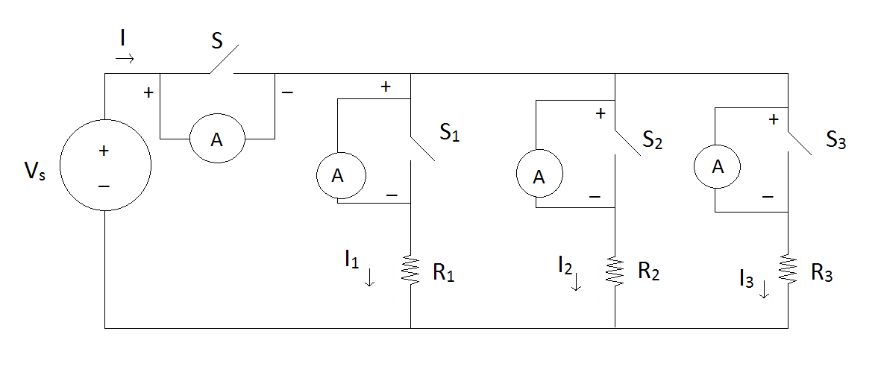

**Fig. 1**

**4. Procedure:**

(i) Measure the resistance of the resistors be using the multi-meter.

(ii) Connect the circuit as shown in **Fig. 1** in breadboard.

(iii) Turn on the DC voltage source and measure it's voltage **Vs** by using the multi-meter. Adjust the voltage changing KNOBs of the voltage source such that the output voltage becomes **I5 V**.

(iv) Connect the ammeter across switch **S** and then open the switch **S** and measure current **I­**by using the ammeter. Close the switch and Open the ammeter.

(v) Connect the ammeter across switch **S1** and then open the switch **S1** and measure current **I­1** by using the ammeter. Close the switch and Open the ammeter.

(vi) Connect the ammeter across switch **S2** and then open the switch **S2** and measure current **I­2** by using the ammeter. Close the switch and Open the ammeter.

(vii)Connect the ammeter across switch **S3** and then open the switch **S3** and measure current **I­3** by using the ammeter. Close the switch and Open the ammeter.

(viii) Perform the calculation below.

**5. Data Table:**

|  |  |  |  |  |  |  |  |
| --- | --- | --- | --- | --- | --- | --- | --- |
| R1 (K) | R2 (K) | R3 (K) | Vs (V) | I (mA) | I1 (mA) | I2 (mA) | I3 (mA) |
| 0.461 K | 0.987 K | 1.479 K | 15 V | 57.67 mA | 31.67 mA | 15.1 mA | 10 mA |

**6. Calculation:**

(i) I1 + I2 + I3 = (31.67 + 15.1 + 10) mA = 56.77 mA

(ii) 100 * (I- ( I1 + I2 + I3)) / I = 100*(57.67 mA - (31.67 mA+15.1 mA + 10 mA)) / 57.67 mA

= 1.55 mA

(iii) Rp = (R1-1 + R2-1 + R3-1 )= (0.461-1 + 0.987-1 + 1.479-1) -1 K = 0.259 K

(iv) Req = Vs / I = (15 / 57.67) = 0.260

(v) 100* (Req - Rs) / Req = 100*(0.260 - 0.259) / 0.260

= 0.38

**7. Questions & Answers:**

(i) Do the experiment results verify the KCL ? Why are you getting some discrepancies ?

**Answer:** From KCL law we know,

"The algebraic sum of the currents entering and leaving an area, system, or node (junction) is zero."

$\sum{I_{entering}}=\sum{I_{leaving}}$

Here, our current **I** is 57.67 mA and the sum of **I1**, **I2**, and **I3** is 56.77 mA.

Difference = (57.67-56.77) mA =0.9 mA

Those two have a little difference. So we can say the experiment results verified the KCL.

We got some discrepancies because of ammeter, which is measuring very low current of circuit and also for the environment.

(ii) Do the experiment result verify the CDL ? Why you are getting some discrepancies ?

**Answer:** From CDL ,

A general formula for the current **Ix** in a resistor **Rx** that is in parallel with a combination of other resistors of total resistance RT is,

I1 = (57.67*0.259)/0.461=32.67

I2 = (57.67*0.259)/0.987=15.13

I3 = (57.67*0.259)/1.479=10.09

And our experiential values are,

I1 = 31.67

I2 = 15.10

I3 = 10.00

These values are around to our experimental values of **I1**, **I2** and**I3**. So the experiment result verified the CDL.

We got some discrepancies because of ammeter, which is measuring very low current of circuit and also for the environment.

(iii) What is the percentage of difference between Rp and Req ? What are the possible reasons for getting this difference ?

**Answer:** The percentage of difference between Rp and Req is 0.38%. The possible reasons for getting differences are for the internal resistance of wire and also for environment.

**8. Discussion:**

(i) For measuring current we have to use the exact value of ammeter Errors less than 10-3 will be ignored.

(ii) Measuring the resistance of resistors we have to remember that human hand can effect on the value of resistance. We have to avoid them.

(iii) When calculating data we should be very careful for approximate values.